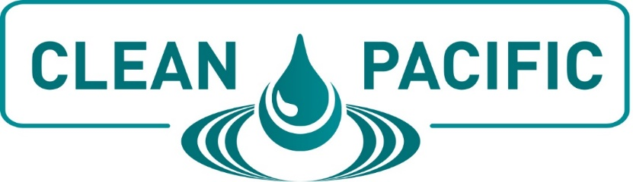

SAMPLE TRIP REPORT

Overview of Event:
The CLEAN PACIFIC Conference was held at the Hyatt Regency Lake Washington in Renton, WA, on August 17-18 and focused on the issues we face regarding spill prevention, response and remediation in the Western United States & Canada.

I had the option to attend all sessions and networking events held at the conference. In addition, I have access to the virtual platform created for this year’s event. The platform will stay open throughout the year so I can continue the conversation with people I met while at CLEAN PACIFIC, schedule meetings with exhibitors I didn’t get to talk to, network with contacts who attended virtually, and watch the sessions on-demand. All of this was included in my conference registration fee.
Why Did I Choose To Attend?
As an environmental and response professional working in the Western United States & Canada, it is important I stay up-to-date on best practices and challenging issues for spill prevention, response and remediation and maintain relationships with all parties involved in incident command and the communities that may be impacted. At CLEAN PACIFIC, I had the opportunity to connect with professionals from maritime, facilities, rail, pipeline and governmental agencies during dedicated networking activities, conference sessions, and on the exhibit floor. The opportunity to learn and connect with everyone was invaluable.
What Sessions Did I Find Most Valuable?
During the conference, I was able to attend numerous sessions. I was able to focus on topics that directly relate to my position at this facility/organization and find solutions for ongoing projects.
Sessions included:
<Insert Name, Speaker and Subject - List as many sessions as desired and included detailed descriptions of each one.>

Provide a listing of what you learned in the session and how it will apply to your organization.
What Networking Events Were Beneficial?
While at CLEAN PACIFIC, I was able to attend the networking breakfasts, lunch and reception. Those events allowed me to visit with vendors, speakers and other attendees.
<List specific people, vendors or speakers you interacted with and the benefits of those discussions.>
Overall Summary of Conference Experience
I was very pleased with my conference attendance and felt it was well worth the registration fee and travel expenses. I learned new solutions and best practice strategies that can be implemented in our facility/organization. In addition, I gained valuable experience that couldn’t be obtained anywhere else. The networking experience was very beneficial. I was able to speak with several industry experts who provided tips and useful information for my particular dilemmas and work projects, and the exhibit hall provided a friendly, informative place to meet with vendors and view their products and services.
In addition, the meals and refreshment breaks allowed me to save on my travel budget and the virtual platform will allow me to continue to benefit from my attendance at CLEAN PACIFIC. Overall, I was very pleased with all that I received at CLEAN PACIFIC and hope to attend again next year.

